../../Downloads/thumbnail_open.png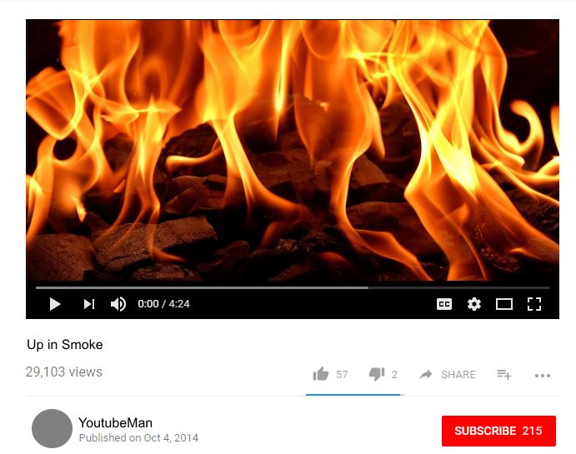

Author’s screen name

Publication date

youtubeman

Published on Sept 12, 2014

Title